Rebecca Leu

Northeastern University  ALY 6050

Non-Linear Programing models

Introduction

This project features two uses of nonlinear programing. Part 1 we cover an optimization transshipment problem looking at supply and demand. Part two switches gears to discuss applications of the hodrick-prescott filter. This time we use nonlinear programing to decompose a time series analysis.

Analysis

Part 1

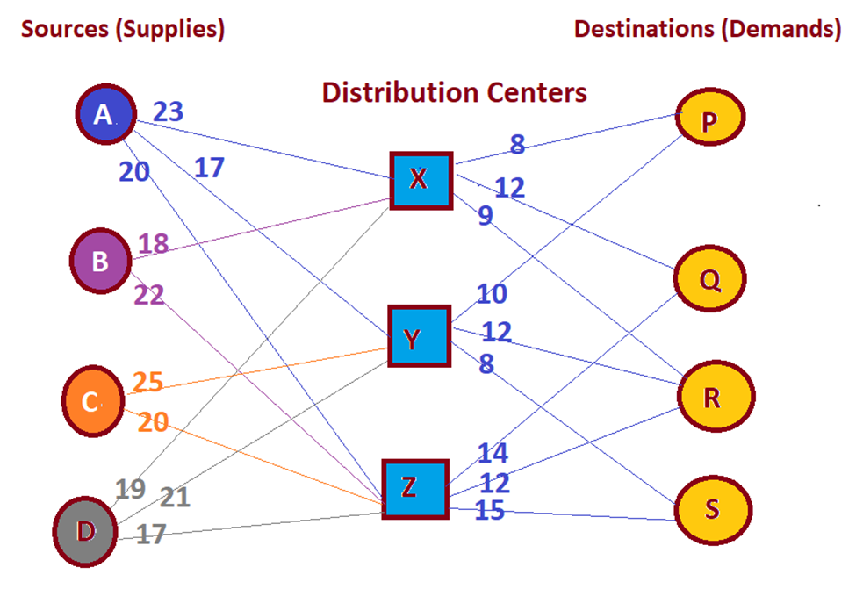

The transshipment problem given is to solve this problem by finding the optimal number of units to be transported from each source to each destination. There are 4 sources, 4 destinations and 3 distribution centers. Each source has a maximum number of supplies to be distributed and each destination has a needed demand to fill. Additionally, the distributions centers can only handle up to 50,00 units to be loaded and unloaded at the facility.

We can set up this problem by creating first the mathematical formulas needed to minimize the optimal transportation cost each year, as well as the constraints of each source, distribution center and destination.

|  |
| --- |
| Minimize Z = ∑ CijXij , i=A, B, C, D, X, Y, Z j= X, Y, Z, P, Q, R, S |
| Sources constraints (supplies): |
| Source A: Xax + Xay + Xaz ≤ 32,500 |
| Source B: Xbx + Xby + Xbz ≤ 41,200 |
| Source C: Xxc + Xcy +Xcz ≤ 18,000 |
| Source D: Xxd+ Xdy + Xdz ≤ 22,500 |
| Destination Constraints (demands): |
| Destination P: Xxp + Xyp + Xzp ≤ 22,500 |
| Destination Q: Xxp + Xyp + Xzp ≤ 35,000 |
| Destination R: Xxp + Xyp + Xzp ≤ 39,700 |
| Destination S: Xxp + Xyp + Xzp ≤ 16,800 |
| Node Constraints (conservation of flow): |
| Node X: Xax + Xbx + Xcx + Xdx = Xxp + Xxq + Xxr + Xxs |
| Node Y: Xay + Xby+ Xcy + Xdy = Xyp + Xyq + Xyr + Xys |
| Node Z: Xaz + Xbz + Xcz + Xdz = Xzp + Xzq + Xzr + Xzs |

We then use the predetermined costs to transport one unit to each of the distribution centers and destinations to determine the most cost-effective way to ship supplies to meet the demands of the destinations.

By first completing a table of the cost to ship the item, we can then use those sources to determine our decision values.

|  |  |  |  |  |  |  |  |
| --- | --- | --- | --- | --- | --- | --- | --- |
| Cost | X | Y | Z | P | Q | R | S |
| A | 23 | 17 | 20 | 1000 | 1000 | 1000 | 1000 |
| B | 18 | 1000 | 22 | 1000 | 1000 | 1000 | 1000 |
| C | 1000 | 25 | 20 | 1000 | 1000 | 1000 | 1000 |
| D | 19 | 21 | 17 | 1000 | 1000 | 1000 | 1000 |
| X | 1000 | 1000 | 1000 | 8 | 12 | 9 | 1000 |
| Y | 1000 | 1000 | 1000 | 10 | 1000 | 12 | 8 |
| Z | 1000 | 1000 | 1000 | 1000 | 14 | 12 | 15 |

|  |  |  |  |  |  |  |  |  |  |  |
| --- | --- | --- | --- | --- | --- | --- | --- | --- | --- | --- |
| Decision Values | X | Y | Z | P | Q | R | S | Shipped from: |  |  |
| A | 0 | 32500 | 0 | 0 | 0 | 0 | 0 | 32500 | ≤ | 32,500 |
| B | 41200 | 0 | 0 | 0 | 0 | 0 | 0 | 41200 | ≤ | 41,200 |
| C | 0 | 0 | 17800 | 0 | 0 | 0 | 0 | 17800 | ≤ | 18,000 |
| D | 8800 | 3219.298 | 10480.7 | 0 | 0 | 0 | 0 | 22500 | ≤ | 22,500 |
| X | 0 | 0 | 0 | 3580.702 | 6719.298 | 39700 | 0 | 50000 | ≤ | 50,000 |
| Y | 0 | 0 | 0 | 0 | 0 | 0 | 16800 | 35719.29848 | ≤ | 50,000 |
| Z | 0 | 0 | 0 | 0 | 28280.7 | 0 | 0 | 28280.70152 | ≤ | 50,000 |
| Shipped to: | 50000 | 35719.3 | 28280.7 | 22500 | 35000 | 39700 | 16800 |  |  |  |
|  | ≤ | ≤ | ≤ | ≥ | ≥ | ≥ | ≥ |  |  |  |
|  | 50,000 | 50,000 | 50,000 | 22,500 | 35,000 | 39,700 | 16,800 |  |  |  |

After inputting the formulas to make sure the decisions line up with the supply and demands of the checkpoints, we use excel solver to determine how much shipment to distribute across the distribution centers and finally to the destinations. Excel solver finds our total minimized transportation cost to be $3,236,300 per year. The final amounts are displayed in the decision values table.

Part 2

The Hodrick-Prescott Filter is a method to decompose time series into cyclical and trend components. It helps to smooth a curve in a time series. This fiter was popularized by Robert J Hodrick and Edward C Prescott, hence the name of the filter, although it was first discovered by E.T Whittaker in 1923. Whittaker was a famous mathematician in Great Britain in the late 1800’s-mid 1900’s.

The Hodrick-Prescot filter equation, as it become known when it was made popular in the 1990’s, has some advantages and disadvantages. The main advantage is that is removes the cyclical component of a time series and it smooths the curve of the time series. But because of this it can also cause wrong predictions because the algorithm changes the data to help adjust for the future.

An example of the usage of the Hodrick-Prescot filter is used with the Honeywell stock prices for a quarter in 2018. Since this is data is a quarter, we use a w of 1600.

hphoneywell<-hpfilter(honeywell, 1600)

plot(hphoneywell)

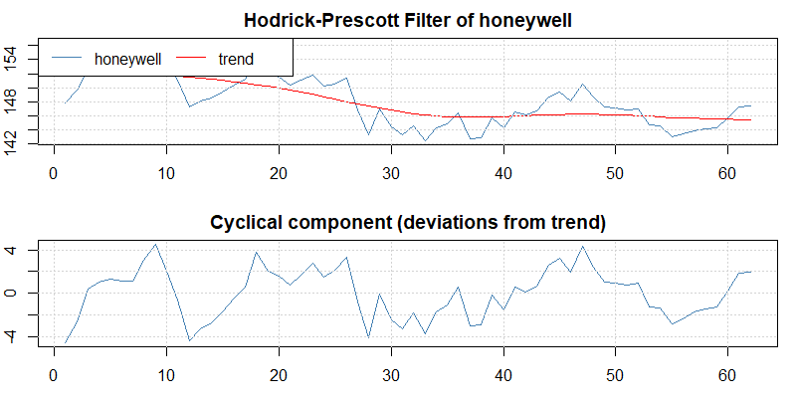

The findings of the HP decomposition show that the trend line is overall negative over the 62 closing numbers.

Conclusion

Quadratic programing can be used to optimize costs for transshipment problems as well as time series analysis of stock data. In the optimization problem presented, using mathematical formulas for minimization and constraint formulas we were able to determine which suppliers transported to which distribution centers and followed through to the destinations that utilized the most minimal amount of transportation costs. In part two we were able to use a quadratic programing towards Honeywell stock prices to see a trend pattern using the Hodrick-Prescott filtering decomposition. Both examples showed how uniquely nonlinear programming can be used to solve vastly different business analytics problems.

Citations:

Hodrick–Prescott filter. (2020, April 05). Retrieved June 27, 2020, from https://en.wikipedia.org/wiki/Hodrick%E2%80%93Prescott_filter

Kenton, W. (2020, January 29). Hodrick-Prescott (HP) Filter. Retrieved June 27, 2020, from https://www.investopedia.com/terms/h/hpfilter.asp